1 This exercise builds off the Blink activity by adding more LED’s (Outputs) and a Switch (Input) to the circuit.

2 Change/Build your circuit to match the diagram below: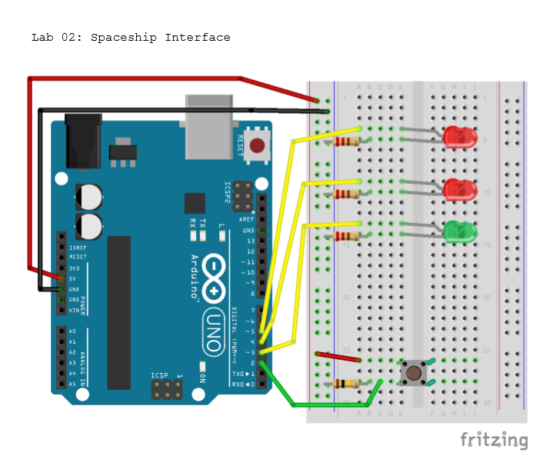

Top Tip: You will need two more LED’s, a pushbutton switch, two more 220Ohm and one 10K Ohm resistors.

3 Open the sketch “p02_SpaceshipInterface” found in the StarterKit_BasicKit section of the Arduino Examples library. Examine the code and read the comments. You need to make the LEDs blink differently according to whether the button is pressed or not!

4 When you have made your changes upload your program to the Arduino and see it in action!

Try changing

1. The way the lights are flashing
2. The sequence of lightsl
3. Add a distance sensor or buzzer to your circuit
4. Move on to the next Challenge!

Additional instructions can be found at

<https://www.arduino.cc/en/ArduinoStarterKit/Prj02>

Sample Code

